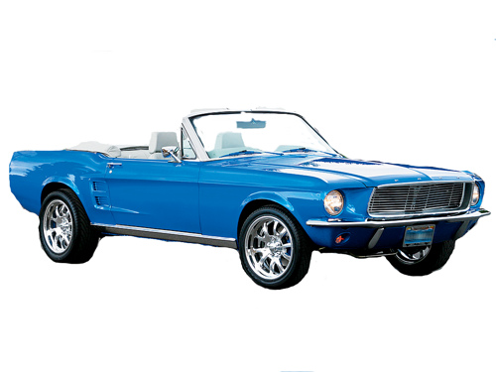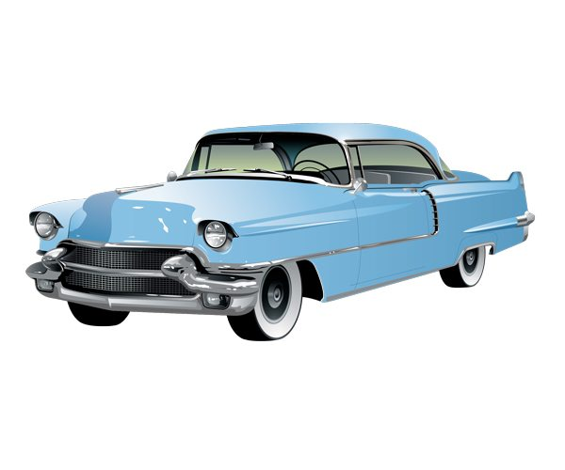  
 ***DIME BOX BLACK BRIDGE FESTIVAL 2017 CAR SHOW ENTRY FORM***

**Date: Saturday, October 7, 2017**

* **REGISTRATION FROM 8:00AM- 10:00AM**
* **Judging 10:30 am – 12:00 PM**
* **Winners Announced after Parade 1:45PM**

NAME___________________________________________________________________________________________

CAR CLUB (if attending with a car club)_________________________________________________________________

MAILING ADDRESS_________________________________________________________________________________

PHONE ______________________________ MOBILE PHONE ______________________________________________

EMAIL ADDRESS___________________________________________________________________________________

VEHICLE YEAR _________________MAKE________________MODEL________________________________________

$25.00 ENTRY FEE (MAKE CHECKS PAYABLE TO DIME BOX LIONS CLUB)

P.O. BOX 144

DIME BOX, TX 77853

For More Information contact Sharon McCoy @ 281-731-7554

ALL ENTRYS MAY PARTICIPATE IN PARADE AT NO ADDITIONAL COST

PARADE STARTS AT 1:00PM

**Waiver of Liability and Release**

On behalf of the entire group participating in the 2017 Dime Box Black Bridge Festival Car Show, I assume all rick of bodily injury, property damage, and personal damage that may occur by participating in the Dime Box Black Bridge Festival Car Show and, for myself/ourselves, their heirs, executors, and administrators, do hereby forever waive and release any and all claims against and agree to hold harmless the Dime Box Black Bridge Festival Car Show. Its committee, sponsors, and volunteers, and the Dime Box Lions Club with their respective officers, agents, representatives, volunteers, successors or assigns and kind from any and all claims which may be made for any cause whatsoever arising as a result of participation. Further, I hereby consent to allow my picture or likeness to appear in any official document, news release, sponsor and /or publish photographic portraits, or pictures, video tape or film of me in which I may be included in whole, part, composite or reproductions thereof in black and white and /or color or otherwise make through any media now known, for art, advertising trade or any other similar lawful purposes whatsoever, including the publicity and promotion of this event itself, including commercial use of or by marketing sponsors.

Print Name __________________________Signature _________________________________

Enclosed is Check # ___________________Check Amount ____________ Date_____________